**Class Project 8**

Use two images for each operation to do the following operations and write down their advantages and disadvantages and explain your results:

1. **Operations:**

* Dilation

**Algorithm:**

Find the local maximum,

① Define a convolution kernel B,

The core can be of any shape and size, and has a separately defined reference point-anchor point;

Usually, a square or disc with a reference point, the core can be called a template or mask;

②Convolve core B and image A to calculate the maximum value of pixels in the area covered by core B;

③ Assign this maximum value to the pixel specified by the reference point;

Therefore, the highlight area in the image gradually grows.

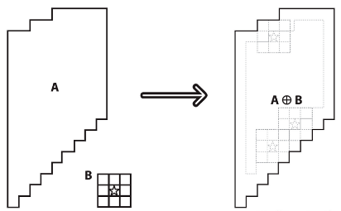

**Results (including pictures):**

Result of processing “noisy_fingerprint.pgm”:

Source Image: Result after dilation:

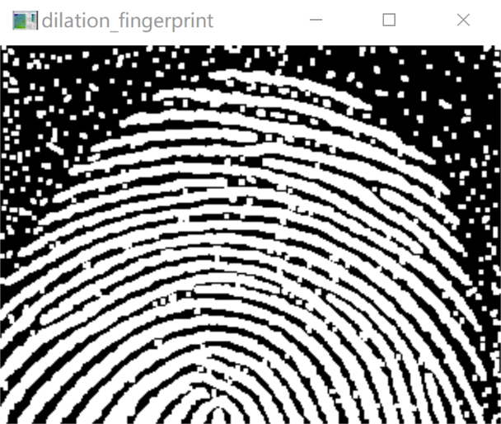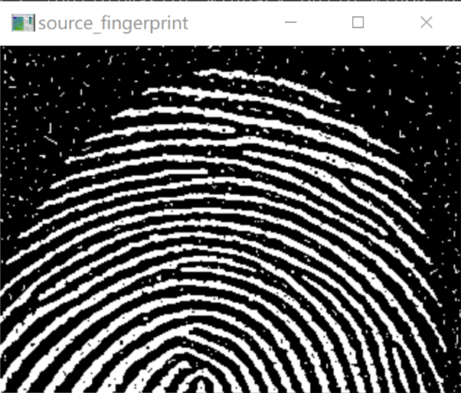

Result of processing “noise_rectangle.pgm”:

Source Image: Result after dilation:

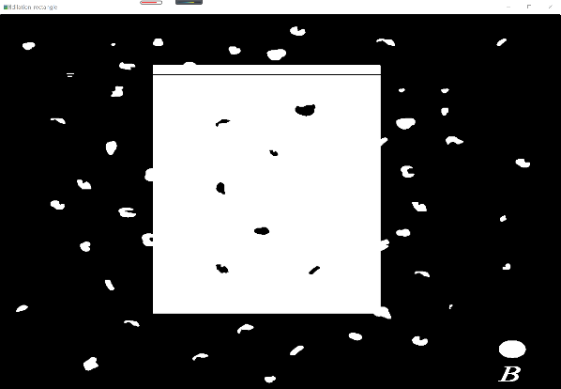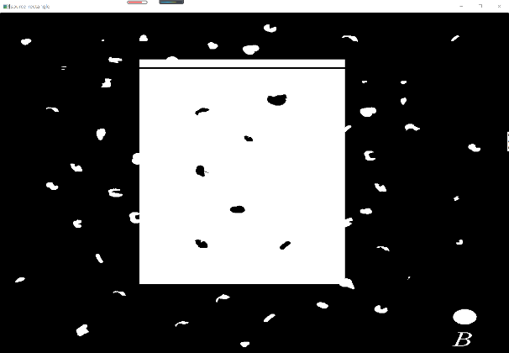

**Discussion:**

Mainly used to eliminate noise;

Separate independent image elements and connect adjacent elements in the image;

Find the obvious maximum value or minimum value area in the image;

Find the gradient of the image;

Corrosion and expansion are for the part with large pixel value, that is, the bright white part instead of the black part;

Expansion is the expansion of the highlighted part of the image, the field is expanded, and the effect picture has a larger highlight area than the original picture;

Corrosion is that the highlight part of the image is corroded, the area is reduced, and the effect picture has a smaller highlight area than the original image;

**Codes:**

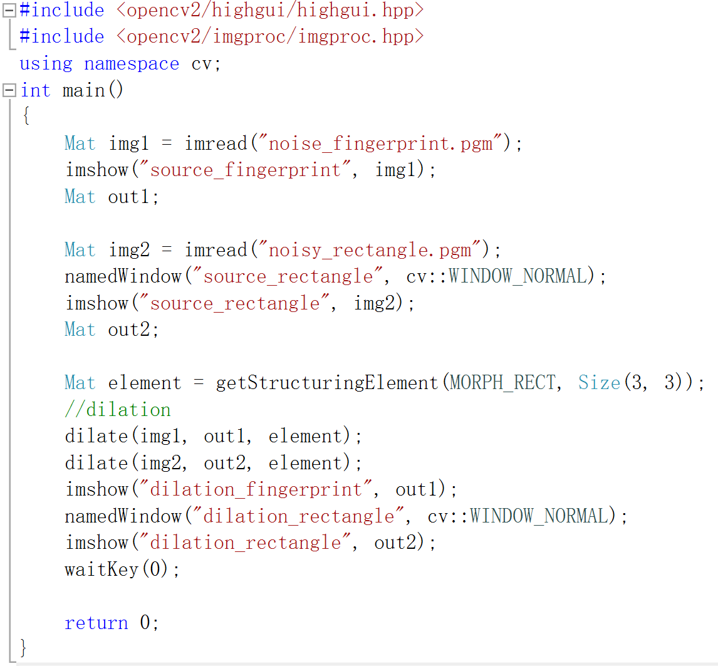

* Erosion

**Algorithm:**

Find the local minimum,

① Define a convolution kernel B,

The core can be of any shape and size, and has a separately defined reference point-anchor point;

Usually, a square or disc with a reference point, the core can be called a template or mask;

②Convolve core B and image A to calculate the minimum pixel point in the area covered by core B;

③ Assign this minimum value to the pixel specified by the reference point;

Therefore, the highlight area in the image gradually decreases.

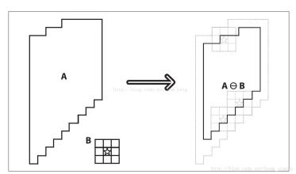

**Results (including pictures):**

Result of processing “noisy_fingerprint.pgm”:

Source Image: Result after erosion:

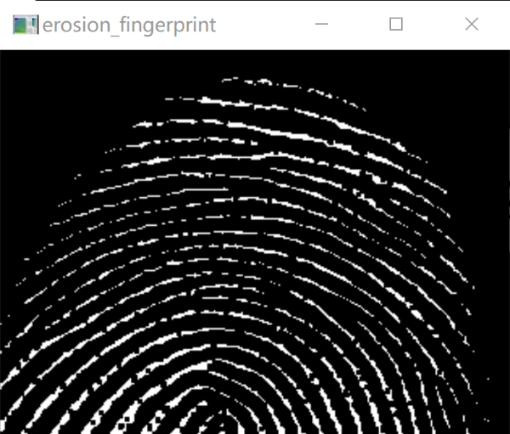

Result of processing “noise_rectangle.pgm”:

Source Image: Result after erosion:

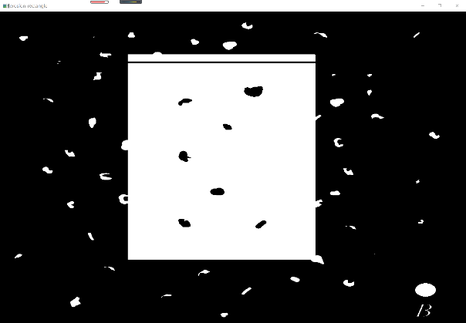

**Discussion:**

Mainly used to eliminate noise;

Separate independent image elements and connect adjacent elements in the image;

Find the obvious maximum value or minimum value area in the image;

Find the gradient of the image;

Corrosion and expansion are for the part with large pixel value, that is, the bright white part instead of the black part;

Expansion is the expansion of the highlighted part of the image, the field is expanded, and the effect picture has a larger highlight area than the original picture;

Corrosion is that the highlight part of the image is corroded, the area is reduced, and the effect picture has a smaller highlight area than the original image;

**Codes:**

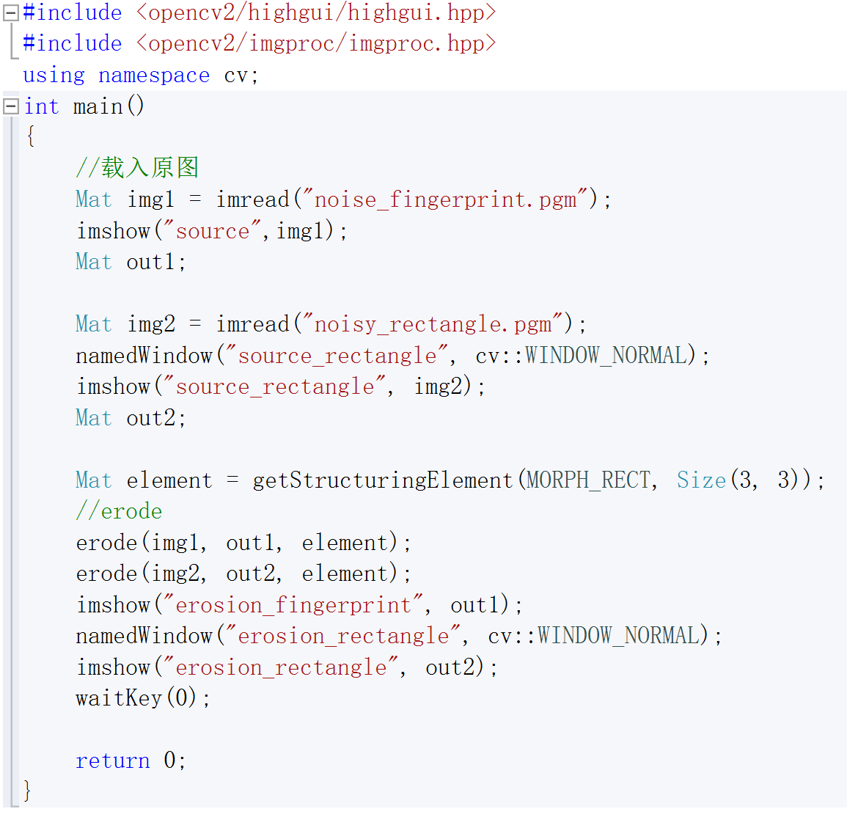

* Opening

**Algorithm:**

The process of first corrosion and then expansion.

Ps. See above for the algorithm of expansion and erosion.

**Results (including pictures):**

Result of processing “noisy_fingerprint.pgm”:

Source Image: Result after opening:

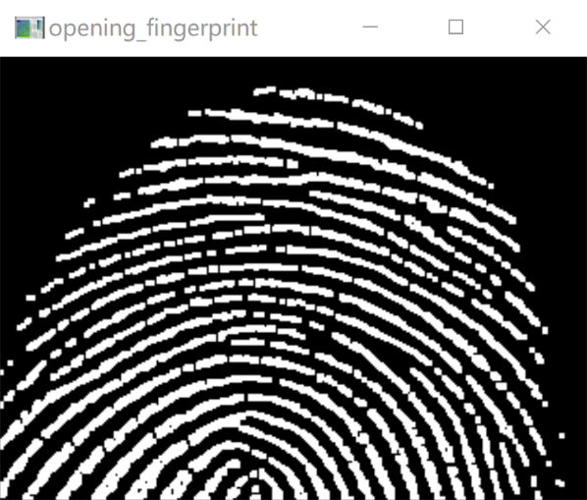

Result of processing “noise_rectangle.pgm”:

Source Image: Result after opening:

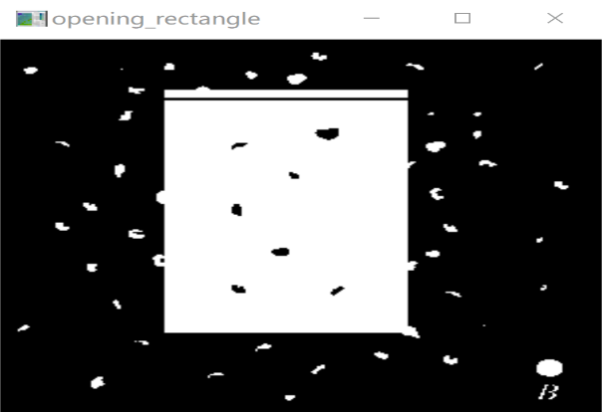

**Discussion:**

Eliminate small objects;

Separate objects in delicate places;

Smoothing the larger border does not significantly change its area;

**Codes:**

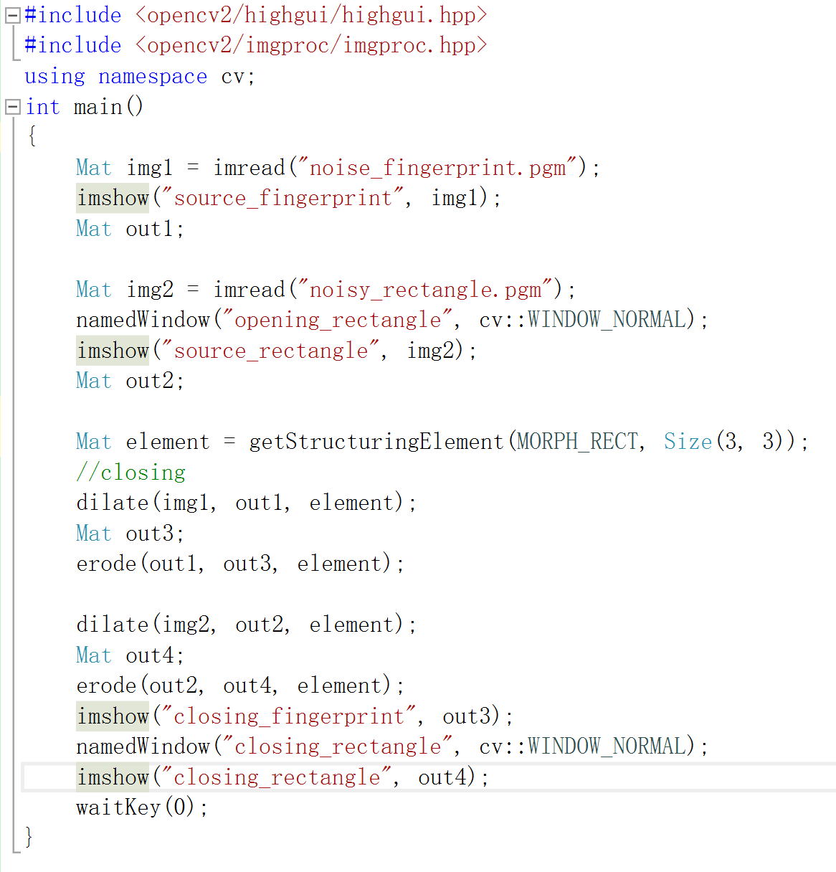

* Closing

**Algorithm:**

The process of first expansion and then corrosion.

Ps. See above for the algorithm of expansion and erosion.

**Results (including pictures):**

Result of processing “noisy_fingerprint.pgm”:

Source Image: Result after closing:

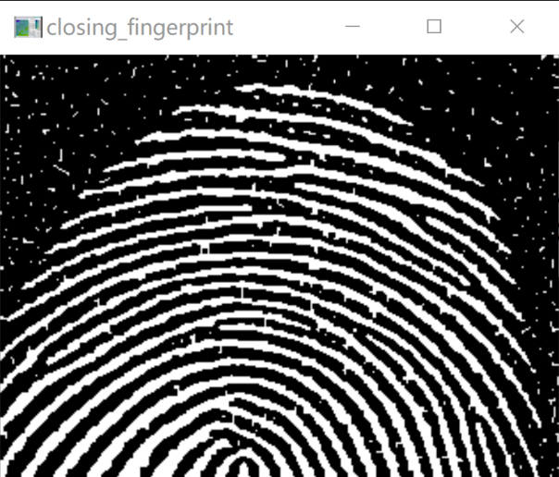

Result of processing “noise_rectangle.pgm”:

Source Image: Result after closing:

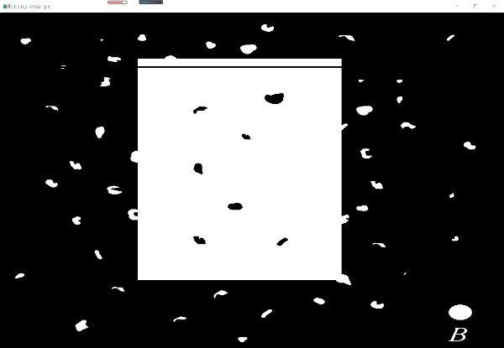

**Discussion:**

Eliminate small black holes (black spots);

Image closing operation connects more image areas.

**Codes:**

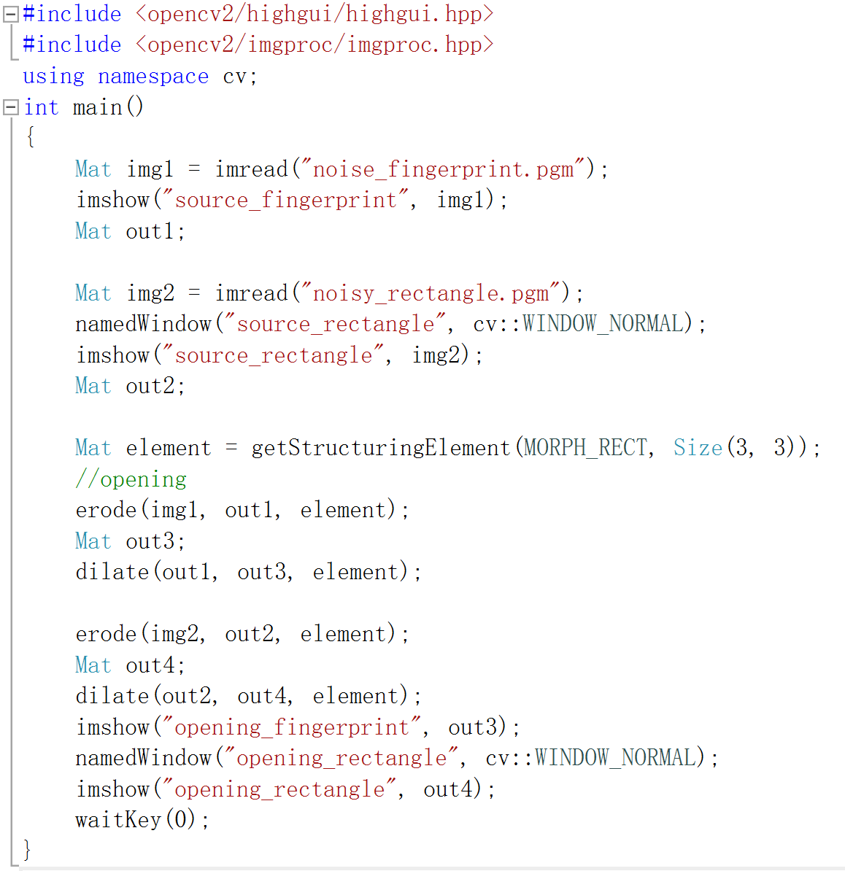

1. **Extract the boundaries:**

**Algorithm:**

Sobel's operator in the x direction:

-1, 0, 1

-2, 0, 2

-1, 0, 1

Sobel's operator in the y direction:

-1, -2, -1

0, 0, 0

1, 2, 1

Calculate in the x direction and in the y direction respectively, find the absolute value, and compress it to the interval [0, 255], that is, is the image after sobel edge detection. Therefore, the sobel operator has two directions.

**Results (including pictures):**

Result of processing “licoln.pgm”:

Source Image: Result after extract:

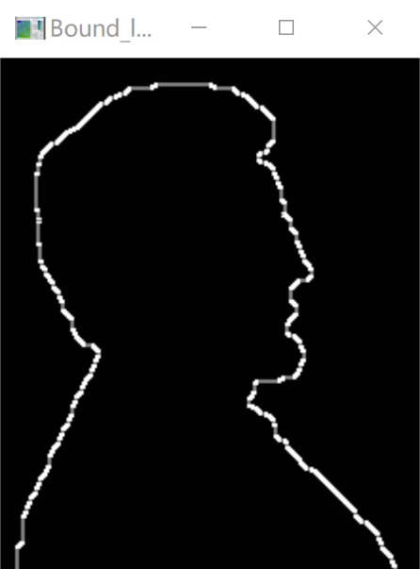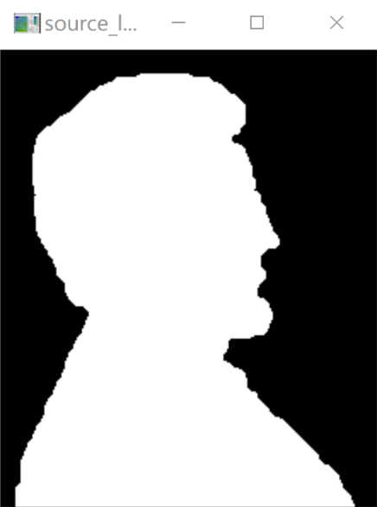

Result of processing “U.pgm”:

Source Image: Result after extract:

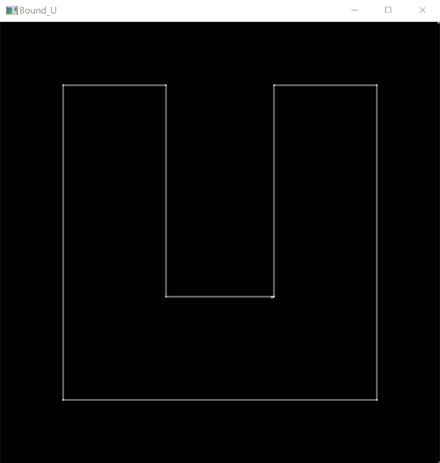 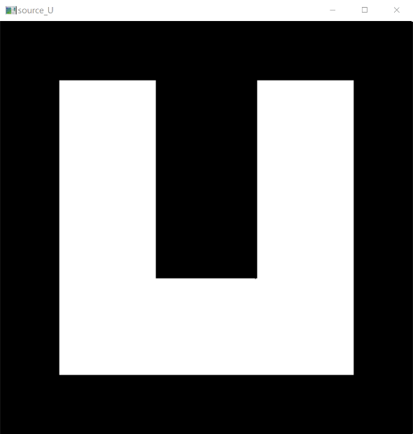

**Discussion:**

The Sobel operator detects the edge based on the gray-scale weighted difference between the upper and lower pixels and the left and right adjacent points, and reaches the extreme value at the edge. It has a smoothing effect on noise, provides more accurate edge direction information, and the edge positioning accuracy is not high enough. When the accuracy requirements are not very high, it is a more commonly used edge detection method

**Codes:**

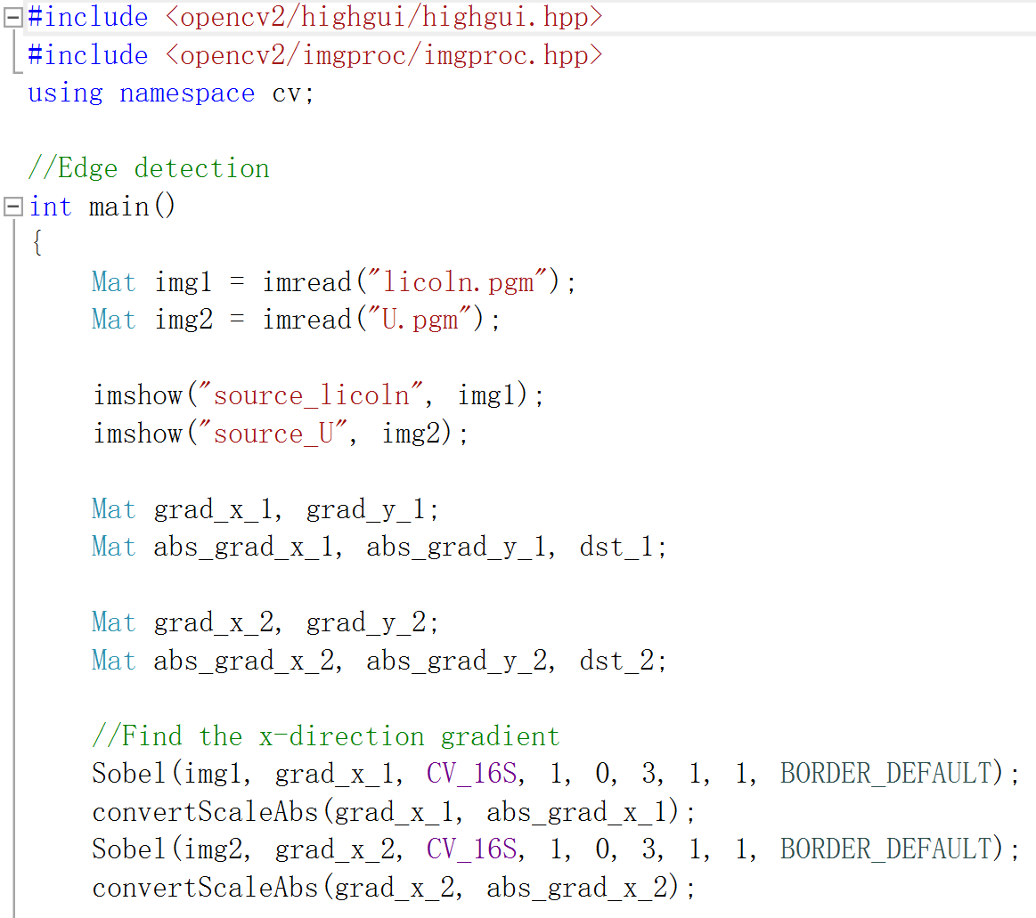

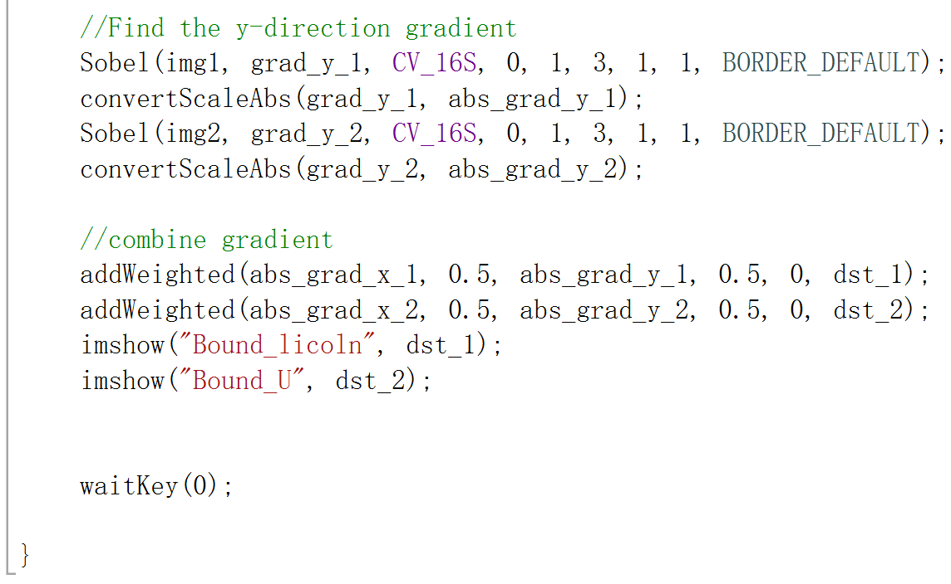

1. **Connected component:**

**Algorithm:**

Use 4-Neighborhood Connected Component Marker,

Start raster scanning from the upper left corner.

If the current traversed pixel is a black pixel, do nothing. If it is a white pixel, examine the upper pixel and the left pixel of the pixel. If both values are 0, assign a new label to the pixel.

*Ps. Here we use numbers as labels, namely 1, 2, 3, 4, etc.*

If one of the two pixels is not 0 (that is, the label is already assigned), the one (except 0) of the labels assigned to the upper and left pixels with the smaller value is assigned to the current traversed pixel . Here, the labels of the upper pixel and the left pixel are written into the Source of the Lookup Table, and the label assigned by the pixelcurrently traversed is written into the Destination.

Finally, comparing the Lookup Table, the label assigned to the pixel is changed from Source to Destination.

**Results (TXT FILE SNAPSHOT):**

Connected Component pixels

1 16

2 16

3 16

4 2

5 42

6 380

7 12

8 1

9 2

10 20

11 90

12 42

13 13

14 1

15 2

16 1

17 144

18 2

19 23

20 2

21 100

22 81

23 16

24 12

25 100

26 24

27 16

28 49

29 400

30 1

31 24

32 144

33 1

34 2

35 49

36 2

37 1

38 16

39 16

40 144

41 2

42 16

43 42

44 144

45 16

46 16

47 81

48 81

49 2

50 7

51 1

52 16

53 16

54 2

55 1

56 2

57 42

58 1

59 16

60 1

61 90

62 1

63 36

64 144

65 100

66 50

67 1

68 2

69 2

70 2

71 2

72 2

73 144

74 24

75 1

76 16

77 42

78 42

79 90

80 81

81 90

82 16

83 2

84 16

85 42

86 144

87 16

88 20

89 24

90 400

91 16

92 16

93 2

94 16

95 1

96 49

97 1

98 2

99 16

100 16

101 2

102 1

103 2

104 156

105 16

106 16

107 20

108 81

109 49

110 16

111 2

112 90

113 2

114 1

115 2

116 16

117 90

118 1

119 81

120 6

**Discussion:**

Connected domain labeling can find the connected space of different areas in an image, and the same pixel near the pixel can be found by using the four-neighborhood. If there is, continue to traverse, and if not, proceed to the next connected domain monitoring. This method can calculate the number of connected regions in a picture and the number of pixels in each connected region.

**Codes:** 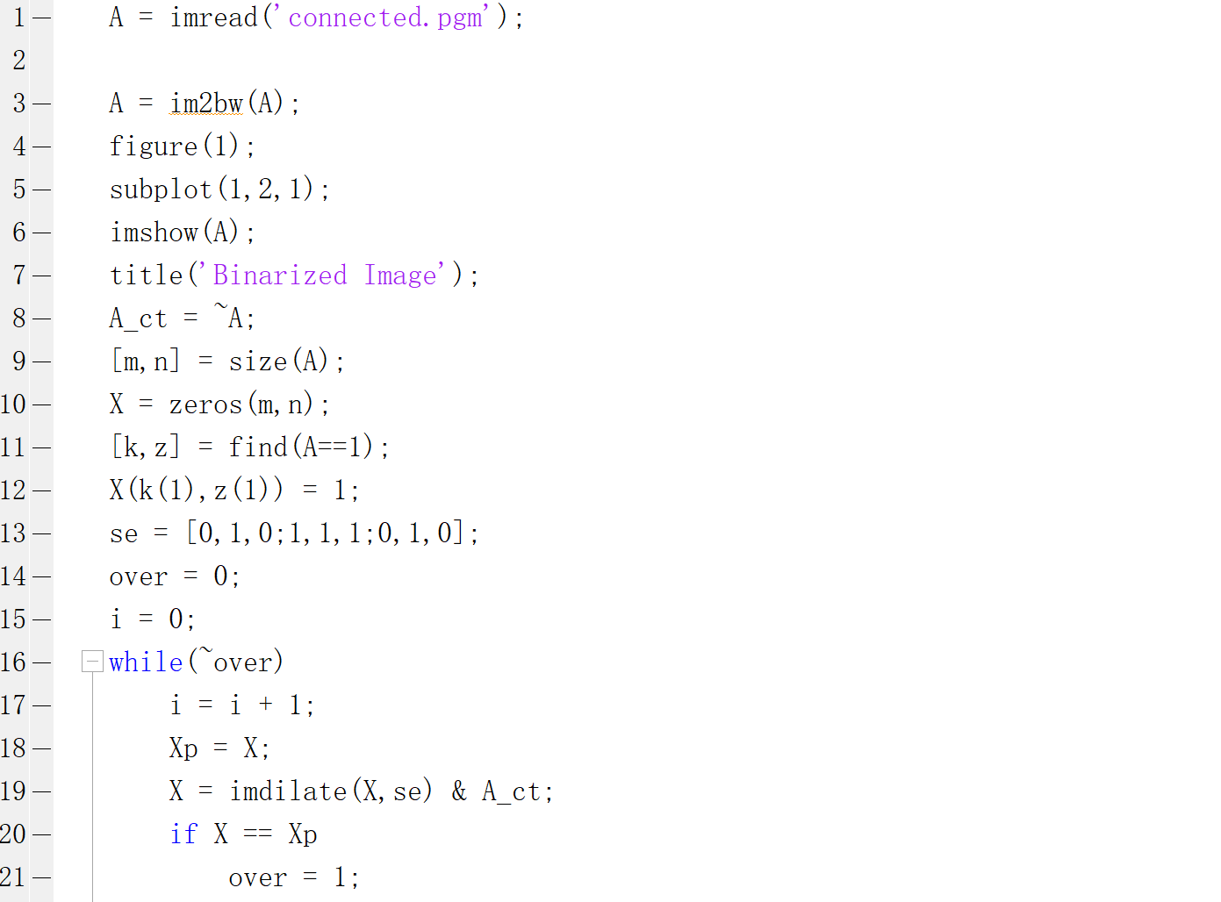 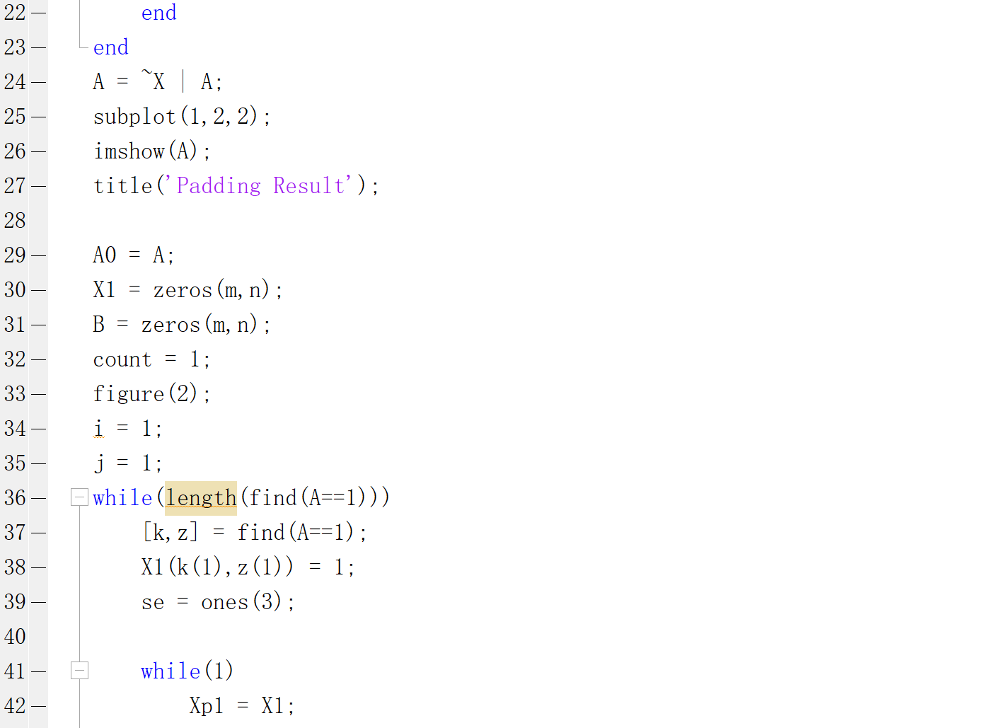 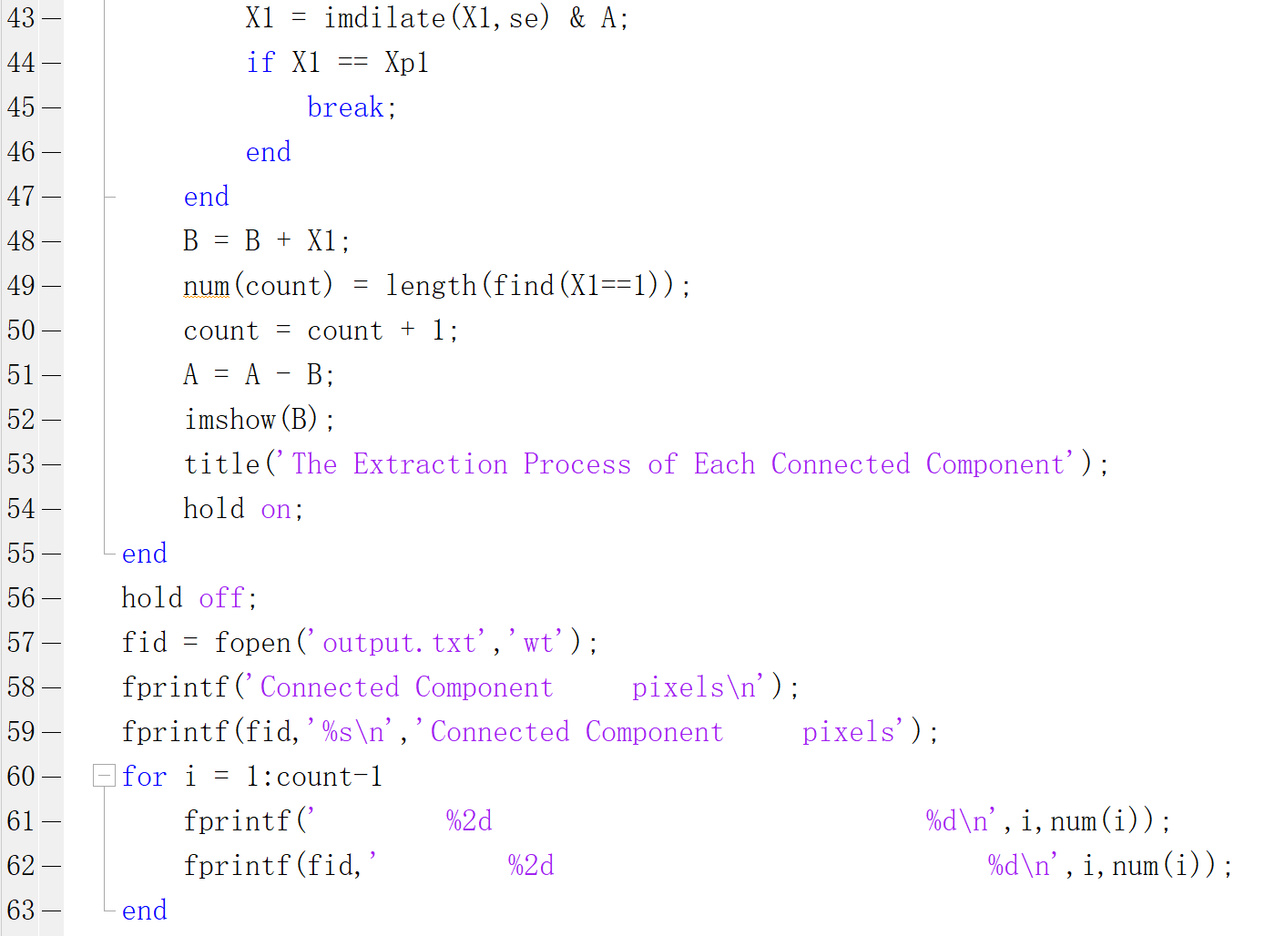 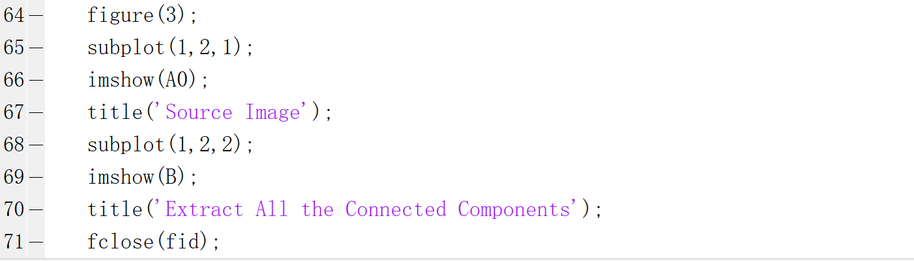

1. **Separate:**

**Algorithm:**

Use area method to process in MATLAB.

Using the area method, we can identify those that are not connected to any circle, because their area is basically equal to the area of a complete circle, and those that overlap each other because their area is basically larger than one circle and smaller than two circles. Then we use The third case can be obtained by subtracting all the connected components from the connected components found. From this we can find several situations required by the title.

**Results (including pictures):**

Result of processing “bubbles_on_black_background.pgm”:

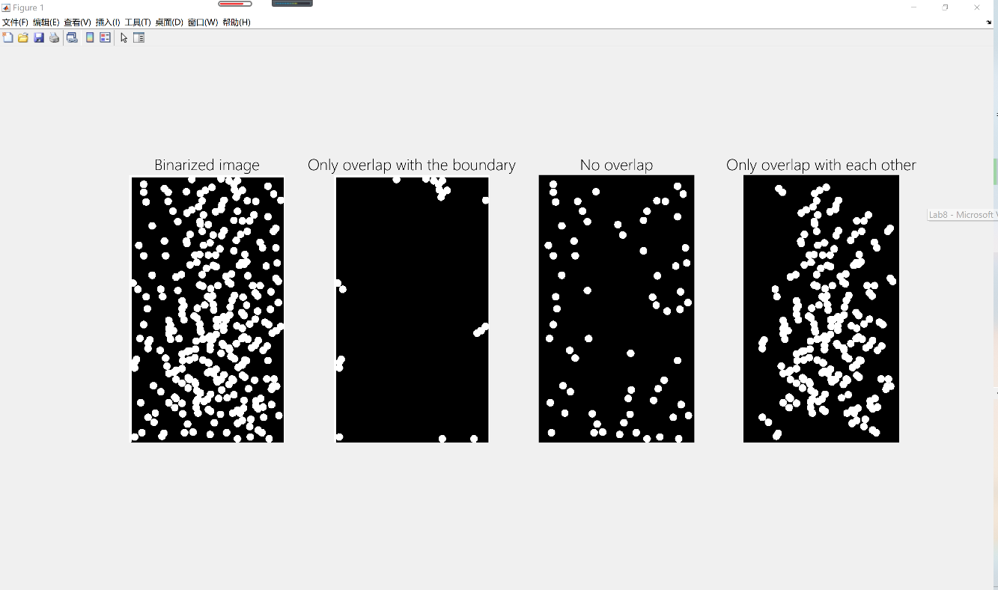

**Discussion:**

Using the area method, we can identify those that are not connected to any circle, because their area is basically equal to the area of a complete circle, and those that overlap each other because their area is basically larger than one circle and smaller than two circles. Then we use The third case can be obtained by subtracting all the connected components from the connected components found. From this we can find several situations required by the title.

**Codes:**

